|  |
| --- |
| Starship Children’s Health |
| Starship PICU Drug Calculator |
| A Guide for website administrators |
|  |
| **Brent McSharry** |
| **Version 0.1.1**  **Last Updated : Thursday, July 04, 2013** |

|  |
| --- |
| A guide on navigating and managing the administration and data modification functions of the PICU drug calculator. Document applicable to website administrators, along with clinicians and pharmacists with login privileges. |

Browser 1

Logging In 1

Edit List Order 3

Manage Users (Where permission has been granted) 4

*Note on assigning permissions* 5

Error Logging 5

Edit Drugs (Where permission has been granted) 5

Resuscitation Drugs 5

Infusion Drugs 6

Fixed Infusions 7

Dilution Methods 8

Titratable Infusions 9

References 10

Hyperlinks 10

Defibrillators (Defibs) 11

## Browser

While the drug calculator user-interface for creating patient specific drug charts uses ‘progressive enhancement’, so that outdated web browsers and browsing with JavaScript disabled is supported, this is not the case for those with any levels of administrator privileges. JavaScript can be enabled under Tools -> Options in most web browsers. The web site will work with Internet Explorer 6 (IE6), although drop-down lists will display through dialogs. This is a fault of IE6, and there is no plan to rectify such behaviour. The administrator pages will work best (in particular, fastest response times) with browser versions released after 2010 (note this does not include IE8, which was last updated in 2008).

## Logging In

You will have been sent an email telling you your username and an auto-generated password. Go to the drug calculator, and click on “Login” (the last menu item on the left), circled in the diagram below. If you do not have any such email in your inbox, please contact a site administrator. At the time of writing, the project is written and maintained by [Brent McSharry](mailto:brentm@adhb.govt.nz).

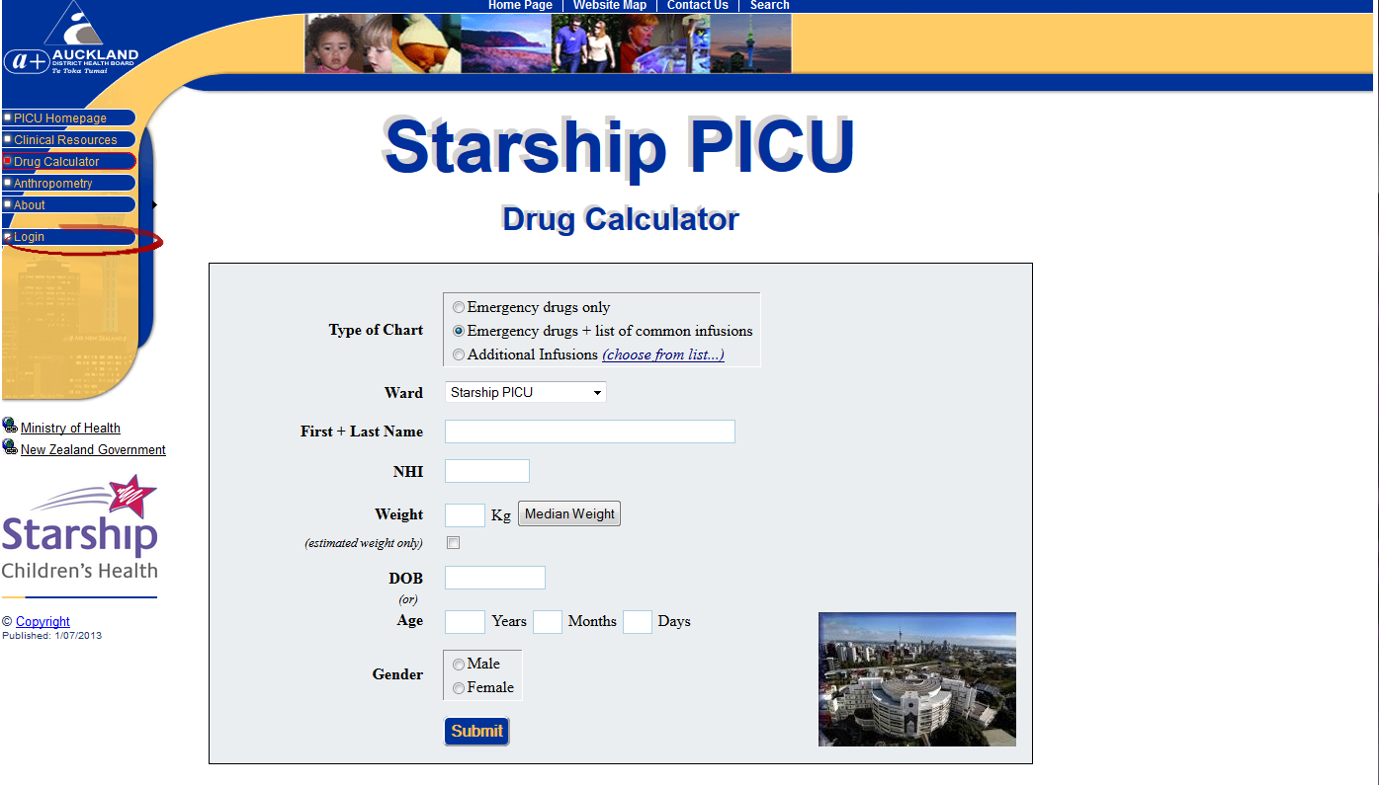

Enter your new login details. You will probably need to copy and paste the password.

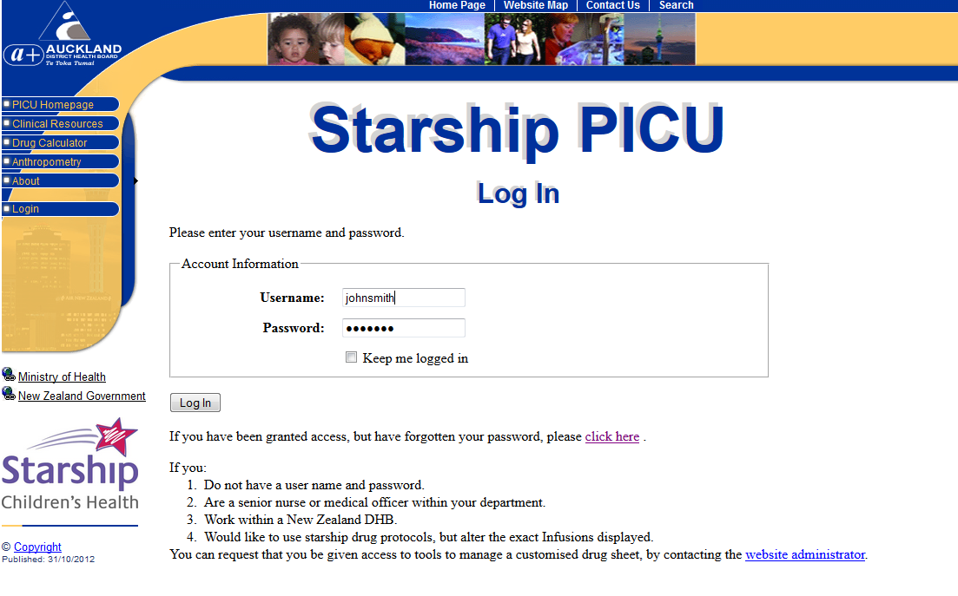

You will be redirected to the page to enter a new password. This is an opportune time to change to a password you will be able to remember:

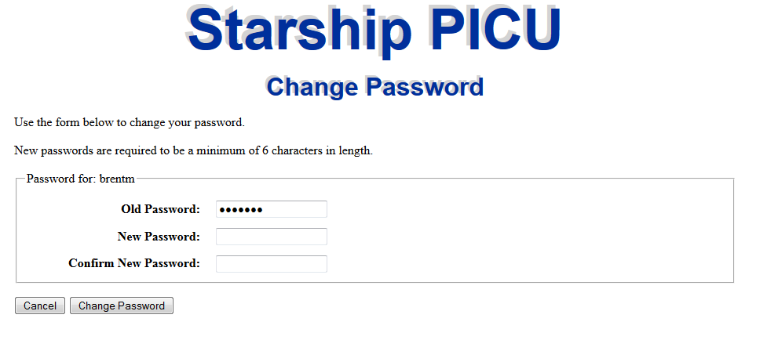

Depending on the access you have been given, you will have a range of new menu items in the left hand menu bar

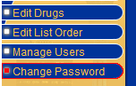

## Edit List Order

This allows you to set up lists for your department, including:

* Which bolus drugs and infusions will be displayed when your department is selected by the end-user.
* The order of any medications to be displayed. These are dragged up and down and between the used and unused medication boxes (in the figure below, ‘Naloxone’ is being dragged across). Once a list has changed in any way, the ‘submit’ button will be activated.
* In the case of bolus drugs, any headings to precede drug groupings.
* The name and abbreviation for your department (used on the ‘entering patient data’ page, where the end user selects which unit protocols to display).
* What kind of defibrillator you use (important so each patient’s dose of defibrillation is rounded to an energy level which is selectable on your defibrillator). These options are accessed by Clicking on ‘Details’, next to your department name.

Note, you will be able to select other departments in order to view their lists and details, but you will not be able to alter the infusions or details relating to any department other than your own. To see information regarding all departments in tabular form, choose the About -> Drug Lists option on the left menu.

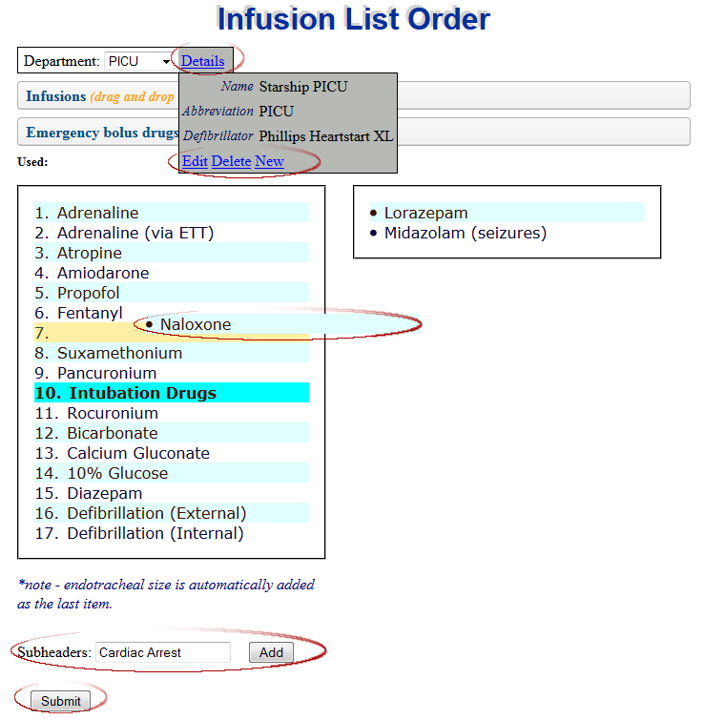

Click on bars to expand/contract details

Naloxone being dragged into position on the ‘Used’ list.

Create header to group together drugs (can be dragged once created)

Edit and create departments

Enabled after any changes

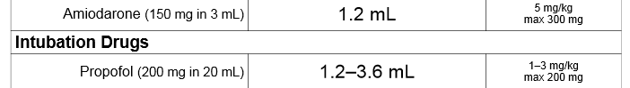

## Manage Users (Where permission has been granted)

When hovering your mouse over the ‘Manage Users’ menu item, the menu will expand to display an ‘Add’ and an ‘Edit’ option. The ‘Add’ option is shown below. The User Name will default to the part of the email before the @ symbol. Departments can be selected, created, deleted or modified if the ‘Select Infusions for a specific Ward’ checkbox is ticked, by clicking on ‘Details’.

An automatically generated email (including a temporary password) will be sent to the address specified once you click submit. The ‘Edit’ menu option allows you to alter email addresses and roles for established users.

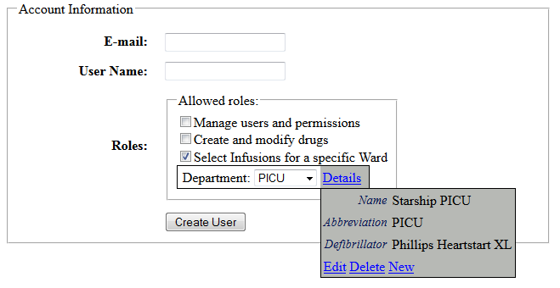

See ‘Edit List Order’

See ‘Edit Drugs’

Add and Edit users, as you are doing now

##### Note on assigning permissions

* Permission to create and modify drugs should be limited to a small number of people who are answerable to the director of intensive care at Starship, and liaise regularly with the Starship resuscitation committee. As an example, at the time of writing, the 3 people with this level of permission were:
  + [Elaine McCall](mailto:EMcCall@adhb.govt.nz) - PICU nurse consultant & chair Women’s and Children’s medication safety committee
  + [Rob Ticehurst](mailto:RTicehurst@adhb.govt.nz) – Principle pharmacist, medication safety
  + [Brent McSharry](mailto:brentm@adhb.govt.nz) – Staff specialist, PICU
* Permission to select infusions for a specific department should be limited to
  + 1 or 2 people from each department
  + Tertiary referral hospitals (at the time of writing, Starship, Middlemore and Christchurch Hospitals are involved).
* Because nurses are pooled to other wards, and junior medical staff rotate through various sub-specialties - wherever possible, sub-specialty wards should use a common ward template. At present, cardiology is the only exception as they run some very specialist infusions which should never be run in any other non-critical care environment. If in doubt about whether to create a new department, please discuss with someone with ‘Create and Modify Drugs’ permission (above).

### Error Logging

At present, asigning someone to the ‘Manage Users and Permissions’ role also gives access to the application error log - accessed at [Application Root]/elmah.axd.

All errors redirect to a generic error screen when the client is remote to the hosting server.

Elmah is held under an [Apache 2.0 licence](http://www.apache.org/licenses/LICENSE-2.0). Documentaion on using elmah can be found on the [elmah wiki](http://code.google.com/p/elmah/w/list). Annotations are provided within the web.config file.

## Edit Drugs (Where permission has been granted)

When hovering your mouse over the ‘Edit Drugs’ menu item, you will see 4 menu items appear:

* Resuscitation Drugs
* Infusion Drugs
* References
* Defibs

### 

### Resuscitation Drugs



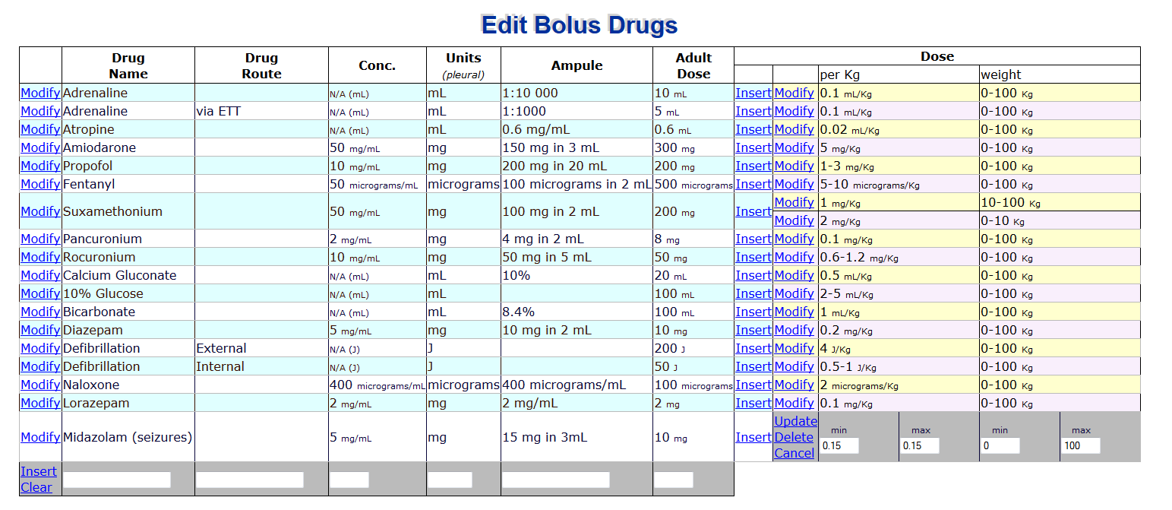

The table contains 2 options to modify or insert - one for the base drug and one for the dose for a particular weight range.

The arrows demonstrate which parts of the drug chart are affected by which field. Note the use of mL, mg and micrograms in the Units column. These abbreviations (including capitalisation) have been developed in conjunction with experts in medication safety and prescribing best practices – please continue to use the same abbreviations.

While physically concentration (Conc.) and ampule denote the same thing, the ampule text is displayed next to the drug name, and the concentration is a number used to calculate the number of mL the end-user should draw up. The text for Ampule is best to be exactly the same text as printed on the ampule itself. Leave concentration blank if no further calculations are required beyond [units or mls]/Kg.

If ‘per Kg’ min and max have the same value, only a single dose is applicable, and the result will be displayed as a single value (as opposed to a hyphen separating the high and low range in the ‘Doses for this child’ column).

Note that weight ranges cannot overlap, so that only 1 dose is ever applicable for 1 individual. The max weight range denotes ≤, thus for suxamethonium (above) 10kg will be calculated on 2mg/Kg and 10.1 kg will be calculated on 1 mg/Kg. To alter the 2mg/kg suxamethonium dose to be applicable to all children up to 15kg, you would 1st need to alter the 1mg/Kg dose from a minimum weight.

### Infusion Drugs



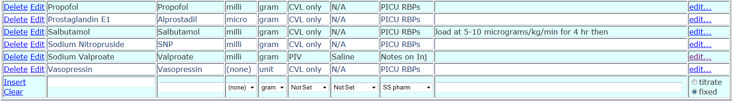

The infusion drugs page allows drugs to be created and modified, and is the portal into modifying infusion details (via the edit… button far right).

[Tall man lettering](https://www.hqsc.govt.nz/our-programmes/medication-safety/projects/tall-man-lettering/) should be used whenever there is potential for confusion or misreading of drug names. Abbreviations (the 2nd column) should be widely accepted, commonly used by clinical staff and unambiguous.

Note the `Titrated’ and ‘Fixed’ options far right:

* Titrated medications include hypno-sedatives and inotropes, have a dose range and are displayed on the ‘Standard Infusions’ chart.
* Fixed infusions include intravenous immunoglobulins and N-acetyl cysteine, are loaded at a standard dose (as opposed to a dose range) for a standard duration, and are displayed to the end-user via the ‘Additional Infusions (choose from list...)’ option on the patient specific drug infusions page.

Because these are 2 conceptually different approaches to drug infusions, and because different information is stored for these 2 infusion types, this cannot be undone once set (aside from deleting and inserting a new drug).

#### Fixed Infusions

By clicking on ‘Edit…’ (far right column), you will be taken to the edit screen for all infusions relating to that drug:

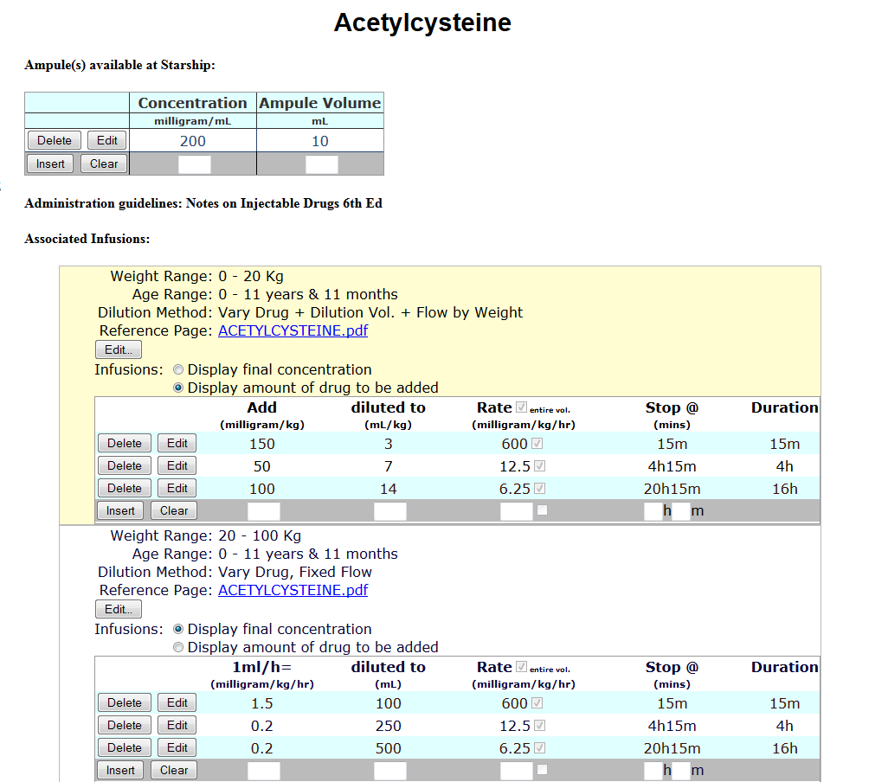

This is to tell the end-user how many mls to draw up. If more than 1 option, the end-user will be asked to select which ampule. Please keep list limited to only ampules stocked in Starship.

Clicking on edit for the 0-20kg, 0-11yr 11 month old:

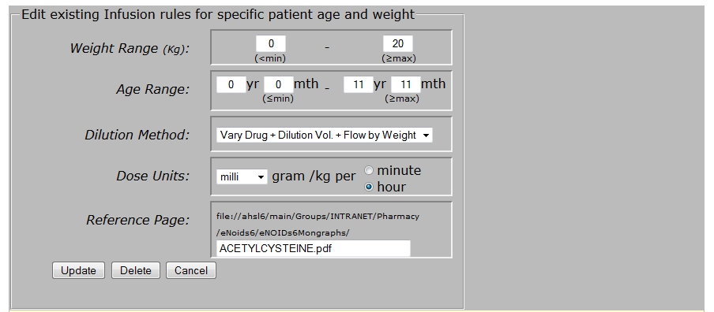

As per bolus drugs, a given patient with a given weight and age can only have one possible infusion.

##### Dilution Methods

The dilution methods are best understood by example:

* Neat, Fixed Flow - Usually for older children, such as run neat propofol @ 100-200 mg/hr.
* Neat, Vary Flow by Weight - Neat, but infusion flow rate varies per kg, e.g. run neat propofol @ 10-20 mg/kg/hr.
* Fixed Dilution, Fixed Flow - As per neat fixed flow, but a given dilution is specified first. E.g. dilute 50 units of actrapid insulin in 50 ml N/Saline and run at 5-10 units per hour.
* Fixed Dilution, Vary Flow by Weight - E.g. dilute 50 units of actrapid insulin in 50 ml N/Saline and run at 0.05 units/kg/hr.
* Vary Dilution Volume, Fixed Flow - Often used with inotropes and more expensive medications in bigger children, so that entire ampules are diluted to different volumes (according to weight), resulting in the same concentration per Kg. The volume is determined as per the [PICU IV infusion chart](http://www.adhb.govt.nz/picu/Protocols/Adult%20Drug%20Infusion%20Chart.pdf).
* Vary Drug, Fixed Flow – The most common method of drawing up infusions for younger children – e.g. milrinone 0.75 mg/kg diluted to 50ml such that 1ml/hr = 0.25 mcg/kg/min.
* Vary Drug + Dilution Vol. + Flow by Weight - Occasionally, medications given as a load, such as N-Acetyl Cysteine will be drawn up as 150mg/kg in 3ml/kg of 5% dextrose, to be given over 15 minutes (note that the duration is the same, but the flow rate to be programmed into the pump varies according to the volume drawn up).

Editing the middle row for N-Acetyl Cysteine

This option affects the display, not the underlying numbers.

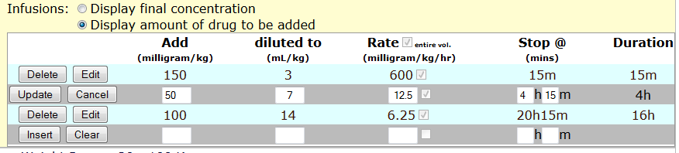

Duration is calculated by stop time entered

This is enabled if the rate field is empty

#### Titratable Infusions

At present, the ampule details are stored for titratable infusions (if you choose to enter details), but this data is not used in the creation of the drug infusion sheets.

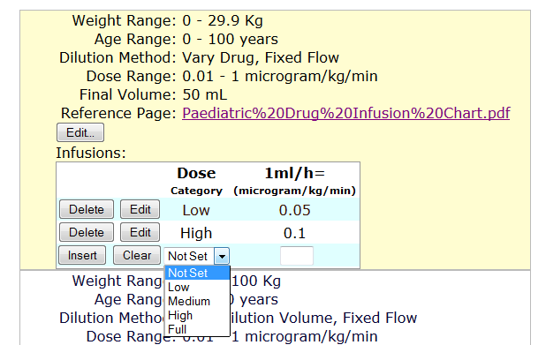

This link can be clicked to ensure the end-user will be able to link to the correct protocol

### References

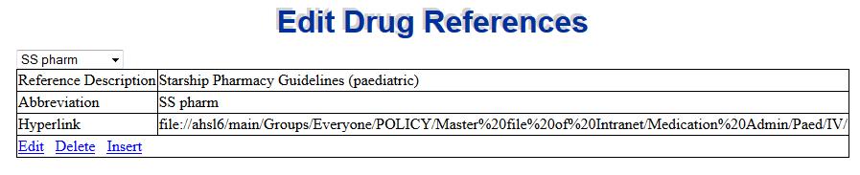

All charts, except the emergency bolus doses (which is guided by the Starship resuscitation committee) contain a reference to a document/protocol/Recommended Best Practice (RBP) from which the infusion was calculated. By design, only one reference source can exist per drug. That is, should the reference be, for instance, to the PICU RBPs, all references must relate to the PICU RBPs (allowing for different documents/webpages within that ‘reference base’ – see below), regardless of the patients age and weight.

#### Hyperlinks

If the reference is to printed material, leave the ‘Hyperlink’ field blank. If the reference is to a directory on the shared ADHB file system (such as the pharmacy guidelines), cut and paste the folder name from the address bar in windows explorer. Similarly, for intra or internet based resources, cut and paste from the address bar at the top of the browser window (make sure you include the ‘http://’ at the beginning, as this lets the application know the address relates to the internet rather than the file system). Internet links provide the least security issues for Adobe Acrobat, and are thus preferable.

The hyperlink may look slightly altered after clicking update (such as back-slashes being changed to forward slashes, prefixing the address with file:// or replacing spaces with %20 symbols) – this is normal behaviour.

### Defibrillators (Defibs)

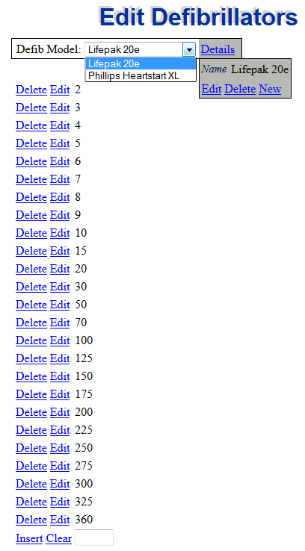

This data is kept to ensure rounding is to an energy level which can be easily selected on the particular model of defibrillator - thus the junior clinician under pressure does not have to do rounding calculations while dealing with the stress of a patient with a malignant arrhythmia. It is therefore important to check the selectable defibrillator energies carefully on the machine itself, before updating or changing these values.